

**“CUSTOMER SALES”**

DEEPALI JAIN

MBA 1STYEAR

SECTION:-B

CU24140066

**SUBMITTED BY:-**

**SUBMITTED TO:-**

**PROJECT FILE**

**2024-2025**

**SESSION:-**

DR. SOURABH

POSWAL

**ROORKEE,**

**UTTRAKHAND**

**COLLEGE OF ENGINEERING ROORKEE**

**Introduction**

The provided data represents a comprehensive analysis of customer demographics, purchasing behaviour, and sales distribution across various product categories for the year 2023. The dashboard highlights key performance indicators such as the total number of customers, transactions, and revenue generated, alongside demographic trends in age, gender, and product preferences.

Key metrics such as the **average customer age (40.29 years)**, **total number of customers (241)**, and **total sales revenue (144K)** give a snapshot of the overall performance. The insights delve into how customers are distributed by age and gender, illustrating that the majority of customers fall within the 30–50 age range, and a slightly higher proportion of customers are female (52.7%) compared to male (47.3%).

In terms of product categories, sales are evenly distributed across **beauty, clothing, and electronics**, with beauty products contributing the highest revenue, closely followed by clothing. Quantity-wise, the clothing category accounts for the largest share (35.68%), indicating its popularity among customers.

The temporal analysis shows a fluctuating customer distribution over time, with notable peaks in activity during specific months. This information can be leveraged to understand seasonal trends and identify key periods of high engagement.

Overall, this report provides an in-depth overview of the customer base and sales dynamics, serving as a foundation for strategic planning and targeted marketing efforts.

**Detailed Report Analysis**

**1. Objective of the Data**

The data is centred on customer purchase behaviour across various product categories over time. The primary objectives seem to include:

* Understanding customer demographics (age, gender) and purchasing trends.
* Analysing sales performance (quantity, revenue) across product categories.
* Identifying patterns and outliers in customer behaviour (e.g., purchase frequency, product popularity).
* Supporting business decisions to optimize product offerings, target customer segments, and maximize revenue.

**2. Overview of the Data**

The dataset includes the following key metrics and dimensions:

1. **Metrics (KPIs):**
   * **Average Age:** 40.29 years.
   * **Total Customers:** 241 unique customers.
   * **Total Quantity Sold:** 723 items.
   * **Total Amount Sold:** 144,000 (currency unspecified).
   * **Total Transactions:** 241 (1 transaction per customer on average).
2. **Dimensions:**
   * **Customer Demographics:**
     + Age Range: 18–64 years, with most customers in their 30s to 50s.
     + Gender Distribution: Nearly balanced, with 52.7% males and 47.3% females.
   * **Product Categories:** Beauty, Clothing, and Electronics.
   * **Purchase Date Range:** January 1, 2023, to January 1, 2024.
   * **Transaction Details:** Quantity per transaction.

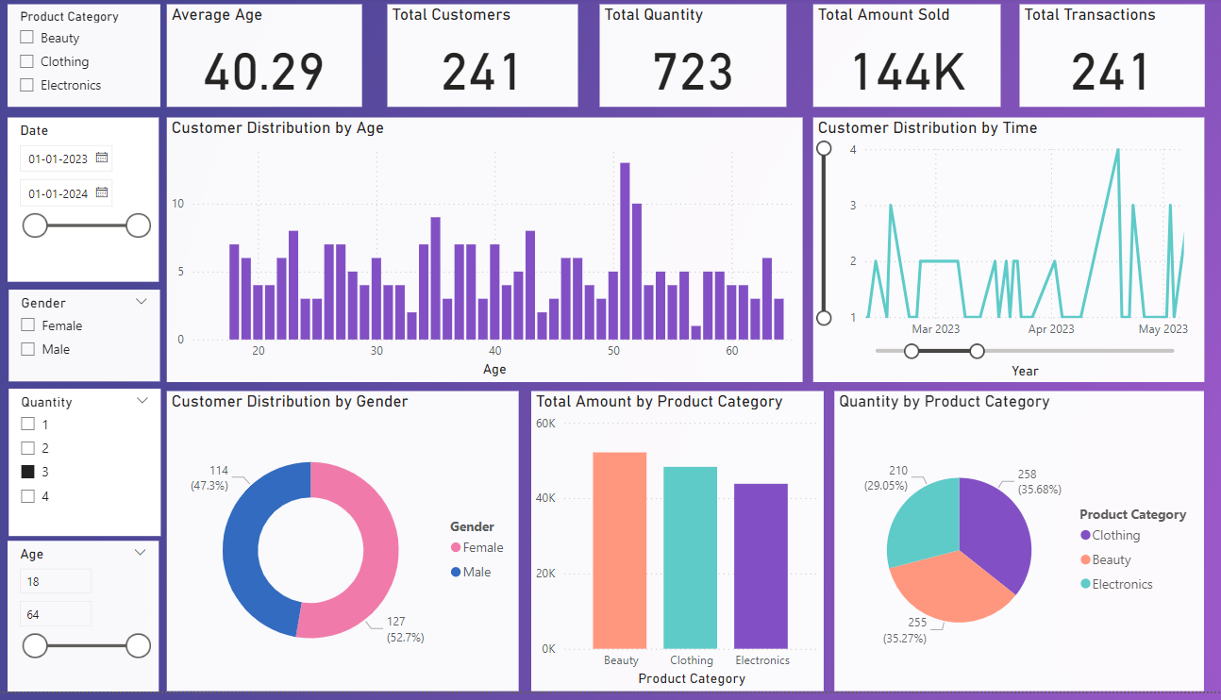

**3. Detailed Insights by Data Categories**

**3.1. Customer Demographics**

* **Age Distribution**:
  + The **average customer age is 40.29 years**, with a balanced distribution between younger and older customers.
  + The 30–50 age range is the most active purchasing group, with peaks around ages 35–40.
  + Outliers: Few customers are younger than 20 or older than 60.
* **Gender Distribution**:
  + **52.7% of customers are male** (127 customers), while **47.3% are female** (114 customers).
  + No significant gender-based bias in sales is visible.

**3.2. Sales Performance**

* **Total Revenue**: 144K across all product categories, with relatively equal contributions from Beauty, Clothing, and Electronics.
  + Beauty and Clothing contribute slightly more revenue than Electronics.
* **Quantity Sold by Product Category**:
  + **Clothing** leads with 35.68% of the total quantity sold (258 items).
  + **Beauty** follows closely with 35.27% (255 items).
  + **Electronics** accounts for 29.05% (210 items).
* **Revenue vs. Quantity**:
  + Despite similar quantities sold, Beauty and Clothing generate more revenue than Electronics. This suggests higher-priced products in these categories.

**3.3. Temporal Trends**

* **Sales by Time**:
  + Customer transactions spike in March and May 2023, possibly due to promotions or seasonal demand.
  + A more detailed analysis of dates might reveal whether weekends or holidays drive higher sales.
* **Purchasing Frequency**:
  + Each customer makes approximately one transaction on average (241 transactions from 241 customers).
  + Analysing repeat customers vs. one-time buyers could offer deeper insights.

**3.4. Product Category Analysis**

* **Category Popularity**:
  + **Clothing** is the most popular category in terms of quantity sold (35.68%), followed by Beauty and Electronics.
  + However, revenue differences between categories are minimal.
* **Customer Demographics by Product**:
  + It would be insightful to see which age or gender groups prefer specific product categories.
  + For example, are males driving Electronics sales or is there a gender-neutral trend?

**4. Used Charts and Their Interpretations**

**4.1. Bar Charts**

* **Age Distribution of Customers**:
  + The histogram of customer ages reveals peaks in specific age groups (e.g., 35–40 years).
  + Purpose: Helps identify the target age group for marketing.
* **Total Amount by Product Category**:
  + Vertical bars compare revenue across categories.
  + Purpose: Highlights the performance of each category in terms of sales revenue.

**4.2. Pie Charts**

* **Customer Distribution by Gender**:
  + Pie chart shows near-equal male and female participation.
  + Purpose: Visualizes demographic balance.
* **Quantity Sold by Product Category**:
  + Pie chart illustrates proportions of items sold in each category.
  + Purpose: Highlights product popularity based on sales volume.

**4.3. Line Charts**

* **Customer Transactions Over Time**:
  + Line graph tracks purchasing activity by month.
  + Purpose: Reveals trends and spikes in customer activity.

**5. Suggestions for Further Analysis**

1. **Deep Dive into Temporal Patterns**:
   * Investigate specific reasons for sales spikes (e.g., promotions, product launches).
   * Compare weekday vs. weekend transactions.
2. **Customer Segmentation**:
   * Cluster customers based on age, gender, and purchasing patterns.
   * Identify high-value customers and potential churn risks.
3. **Profitability Analysis**:
   * Analyse profit margins for each product category, not just revenue.
   * Focus on cross-selling and upselling strategies for underperforming categories.
4. **Trend Projections**:
   * Use predictive analytics to forecast future sales and identify potential growth areas.

**5. Follow-Up Questions**

**Q1. Why does customer activity fluctuate over time?**

* **Possible reasons**:
  + Seasonal trends (e.g., holidays, back-to-school, or end-of-season sales).
  + Promotions or discounts during specific months (March and May spikes).
  + External factors like economic conditions or product launches.

**Q2. Which product categories are growing or contributing most to revenue?**

* **Clothing** leads in both quantity sold (35.68%) and revenue.
* **Electronics** lags slightly behind in revenue despite decent sales volume, likely due to lower price points or discounts.
* **Beauty** products are performing well with high revenue and nearly equal quantity to Clothing.

**Q3. Which demographics drive product categories?**

* Detailed customer-category mapping is not visible in this dashboard. However:
  + **Age**: The 30–50 age group likely drives most sales, as they dominate the customer base.
  + **Gender**: There is no significant bias; both genders contribute nearly equally.

**Q4. Are there outliers in sales (e.g., high-value transactions)?**

* The dashboard does not show specific transaction values. However, high revenue in Beauty and Clothing suggests potential outliers in those categories.

**Q5. How does quantity sold relate to revenue?**

* Categories like Beauty and Clothing generate more revenue per unit, while Electronics might be sold at lower prices or discounted rates.

**6. Suggestions for Further Analysis**

1. **Detailed Transaction Analysis**:
   * Identify high-value customers and their purchasing patterns.
   * Track the frequency of repeat customers.
2. **Product Performance**:
   * Assess profit margins for each category and optimize pricing strategies.
3. **Temporal Insights**:
   * Compare year-over-year trends and seasonality to predict future spikes.
4. **Customer Segmentation**:
   * Cluster customers by demographics and spending behavior to create targeted campaigns.
5. **Promotional Impact**:
   * Overlay promotion dates on sales data to measure effectiveness.

**1. Time-Related Trends: Why Customer Activity Fluctuates**

**Exploring the Fluctuations:**

* **Promotional Campaigns**: The spikes in customer activity (especially in March and May 2023, as shown in the temporal graph) might be linked to promotional events, sales campaigns, or special offers that drive higher traffic and purchases. You can investigate this by checking if there were any targeted marketing activities during these periods, such as discounts, flash sales, or special product launches.
* **Seasonality Effects**: Some product categories, such as Beauty and Clothing, may experience higher demand during specific seasons (e.g., winter clothing, holiday gifts). Understanding when the spikes occur relative to the calendar (e.g., holidays like Christmas, Black Friday, etc.) could provide insights into seasonality.
* **Product Launches or Trends**: Certain spikes could also be driven by the launch of new products or trends in specific categories (e.g., a hot new beauty product or clothing style). Tracking launch dates and comparing them with spikes in the data will help identify such influences.

**Further Investigation:**

* You could overlay sales data with marketing campaign or promotional period information to verify if sales spikes are aligned with such activities.
* Analyzing data from previous years (if available) can help confirm whether these trends are seasonal or driven by external factors.

**2. Category Insights: Product Categories and Profit Margins**

**Contributions of Product Categories:**

* **Revenue vs. Quantity**: Although the dashboard shows that **Clothing** and **Beauty** are leading in revenue, understanding their **profit margins** will be key. For instance, if the **Electronics** category has lower margins due to discounts or lower-priced items, but high volume, it might still be important for driving total sales volume.
* **Category Growth Over Time**: By analyzing the time-based data, you can look at trends for each category across months. For instance, if **Beauty** sales grow faster over time than **Clothing**, it might indicate a rising trend in demand. You could perform a **CAGR (Compound Annual Growth Rate)** analysis to measure which category is growing at the fastest rate.

**Further Investigation:**

* **Profitability Analysis**: To truly understand which categories contribute the most to your bottom line, you’d need data on **cost of goods sold (COGS)** for each category. If that’s available, we could calculate **gross margins** for each product category to identify which categories are the most profitable.
* **Sales Trends**: For growth insights, apply time-series analysis to identify whether certain product categories show accelerated growth or seasonal peaks.

**3. Customer Segmentation**

**Age Groups & Gender Driving Sales:**

* **Age-Based Insights**: If the data provides the ability to correlate **age groups** with specific categories, we could identify which age group purchases more from a specific category (e.g., if younger customers prefer **Beauty** and older customers favour **Clothing**).
* **Gender-Based Insights**: Analysing gender with respect to product categories could reveal if certain genders dominate specific categories. For example, **Beauty** might be more popular with females, whereas **Electronics** could have a more balanced or male-dominated customer base. Identifying these trends will help tailor marketing strategies accordingly.

**Outliers in Customer Segmentation:**

* **High-Value Customers**: Investigating if any customers are responsible for a disproportionate share of sales could help identify **high-value customers**. You could segment them based on their **purchase history** (e.g., repeat customers or customers who purchase high-ticket items).
* **Demographic-Driven Outliers**: You could also look at **outlier transactions**, such as extremely large purchases or specific demographics that drive these high-value transactions.

**Further Investigation:**

* **Segmentation**: We could segment customers by age, gender, and purchase frequency. A customer segmentation model would help group customers by behaviors and preferences.
* **Targeting High-Value Segments**: If you have a **high-value segment** (e.g., older customers or males buying high-end electronics), marketing strategies could be designed to retain and encourage these segments to purchase more frequently.

**4. Outliers in Sales: Unusually High or Low Sales Days**

**Identifying Outliers:**

* **High Sales Days**: These could be caused by promotional campaigns, product launches, or special events. You can identify the dates of unusually high sales and cross-check against any marketing activities or external factors (like holidays or trends).
* **Low Sales Days**: Similarly, **low sales** could be linked to factors like product unavailability, market conditions, or customer hesitation due to external factors (e.g., economic downturn or price competition).

**Further Investigation:**

* **Sales Anomalies**: Look for days with outlier transactions in terms of both quantity and revenue. A significant drop in sales might indicate issues with the website, product stock, or competitor actions.
* **Correlation with External Events**: You can correlate low sales days with any external event (e.g., a competitor’s sale, poor reviews, or product delivery delays).

**Next Steps for In-Depth Analysis**

* **Sales Trends Over Time**: Apply **trend analysis** or **seasonal decomposition** methods to investigate the fluctuations in customer activity.
* **Profit Margins**: If you have cost data, calculate **profit margins** for each product category to better understand profitability beyond sales volume.
* **Segmentation Models**: Use **clustering algorithms** (like K-means) or **RFM (Recency, Frequency, Monetary)** analysis to segment customers and identify key groups driving sales.
* **Outlier Detection**: Use statistical methods like **Z-scores** or **IQR (Interquartile Range)** to identify extreme high and low transaction days.